1.) TCP Server-Client Communication:

Problem Statement: Write a TCP server and client program in C where the server listens for incoming connections and echoes back any message it receives from the client. The client should be able to send a message to the server and display the echoed message.

Requirements:

The server should run indefinitely, waiting for client connections.

The client should take a message as input from the user, send it to the server, and display the response.

Implement proper error handling and cleanup (e.g., closing sockets).

Server code

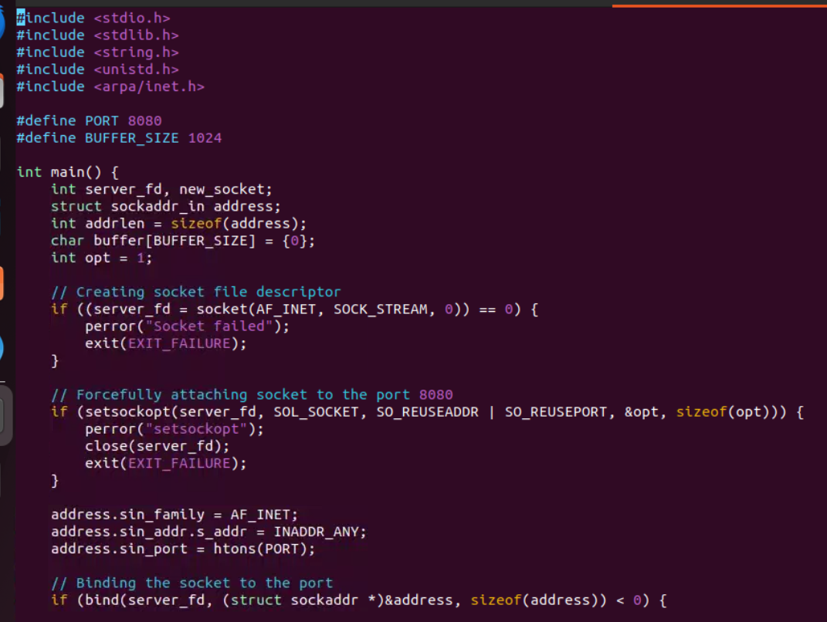

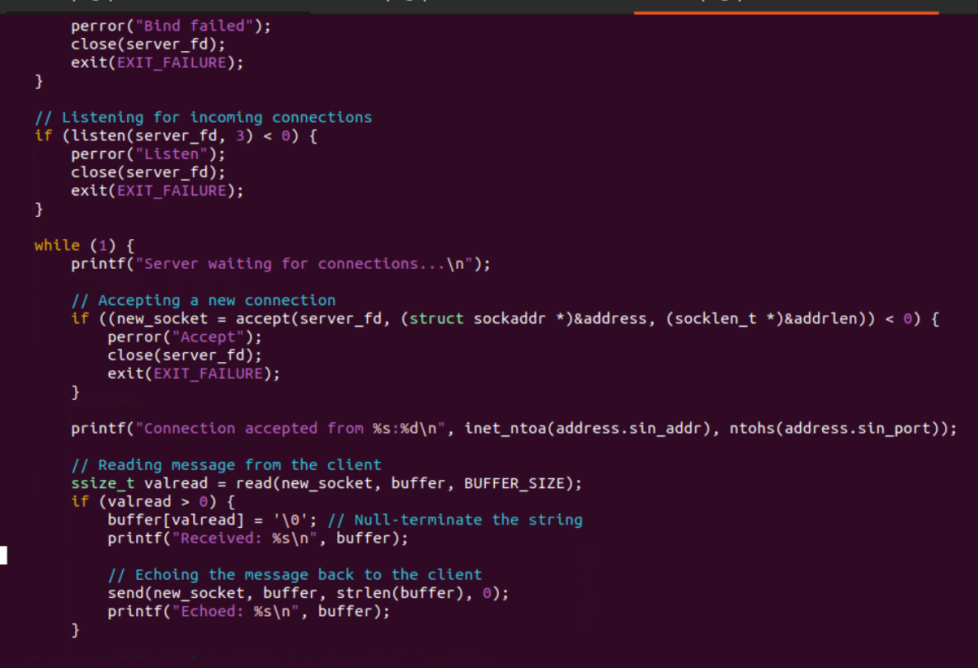

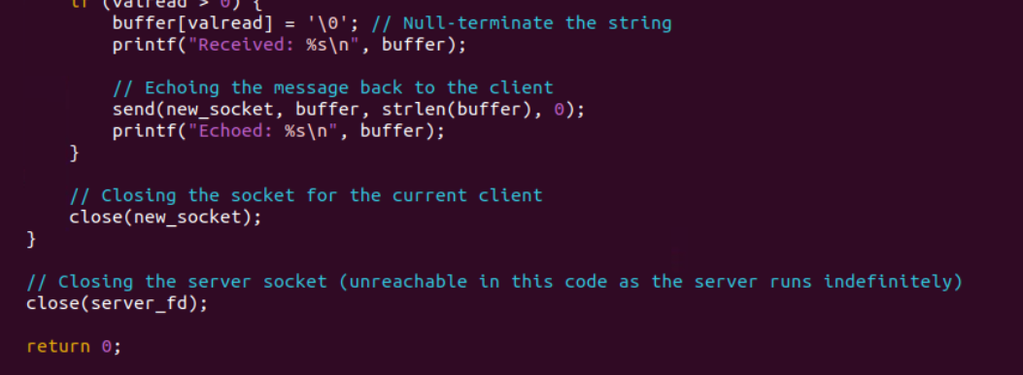

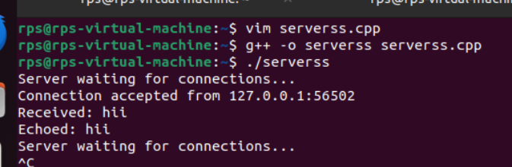

Client code

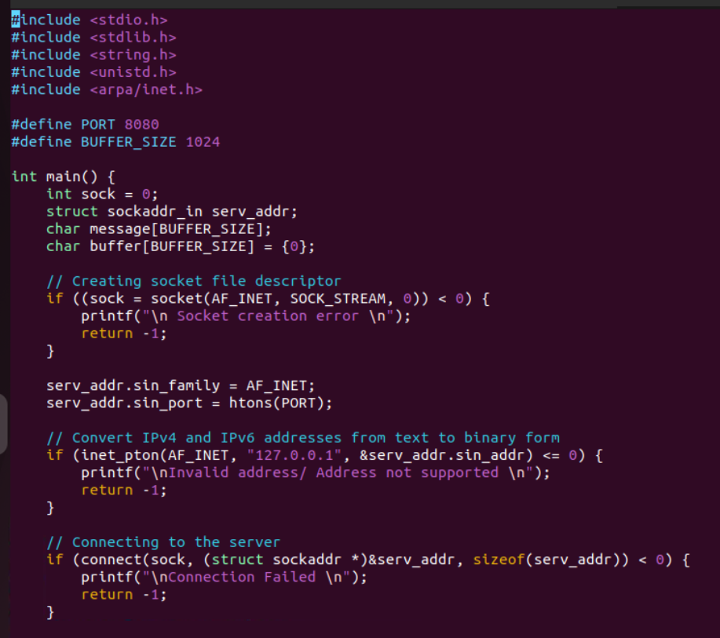

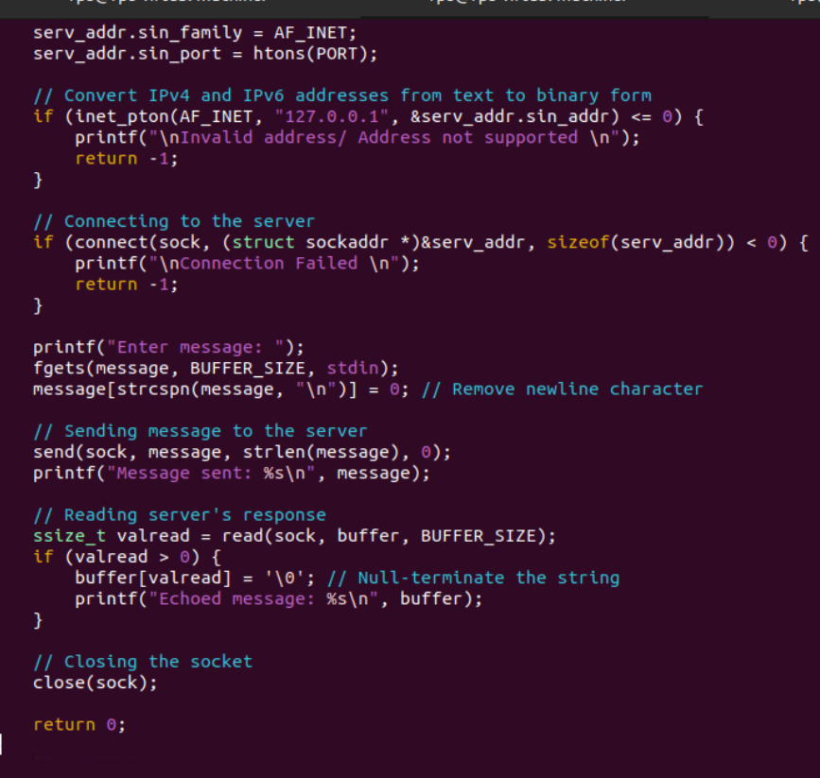

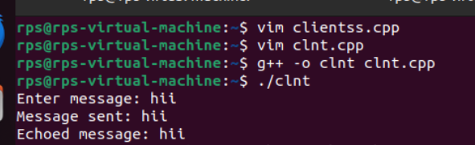

2.) UDP Server-Client Communication:

Problem Statement: Write a UDP server and client program in C where the server listens on a specific port and responds with "Hello, Client!" whenever it receives a message. The client should send a message to the server and print the response.

Requirements:

The server should run indefinitely, waiting for incoming messages.

The client should send a predefined message (e.g., "Hello, Server!") and display the server's response.

Implement proper error handling.

Server code

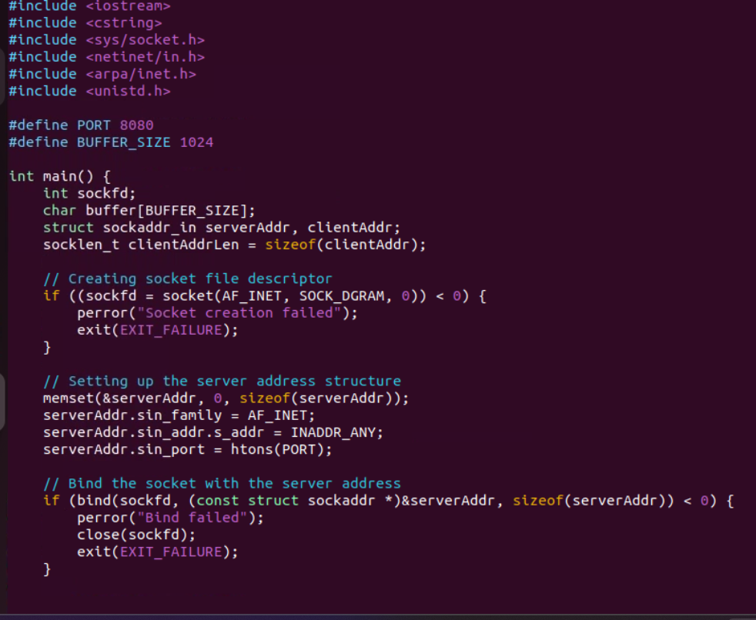

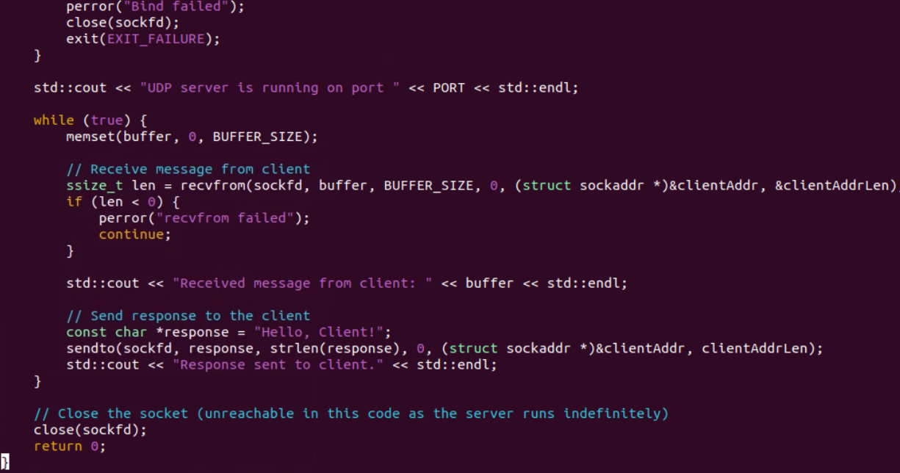

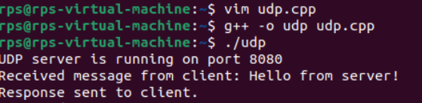

Client code

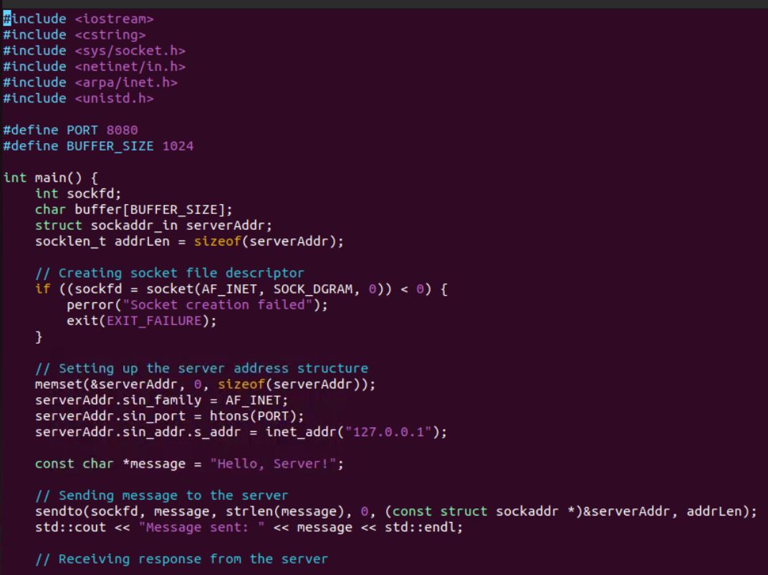

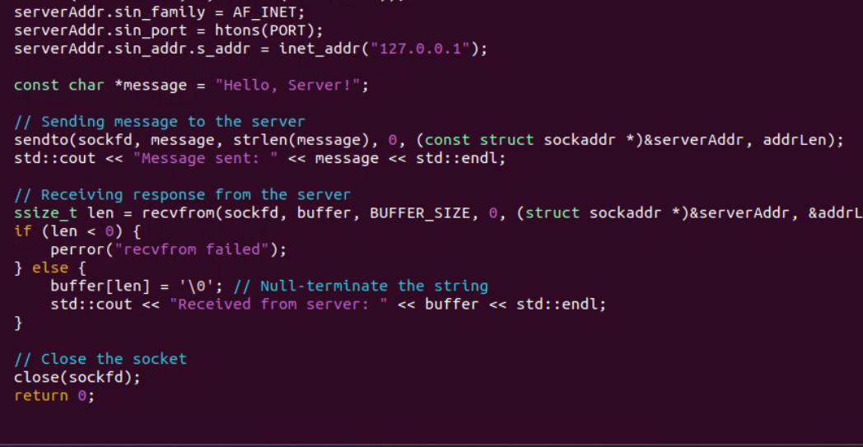

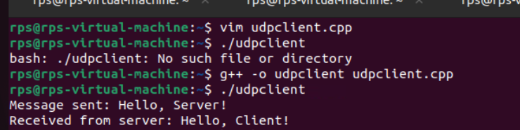

3.) File Transfer using TCP:

Problem Statement: Write a TCP server and client program in C to transfer a file from the client to the server. The server should save the received file with the same name, and the client should specify the file to be sent.

Requirements:

The server should run indefinitely, waiting for file transfer requests.

The client should prompt the user for a file path, read the file, and send its contents to the server.

Implement proper error handling and file operations.

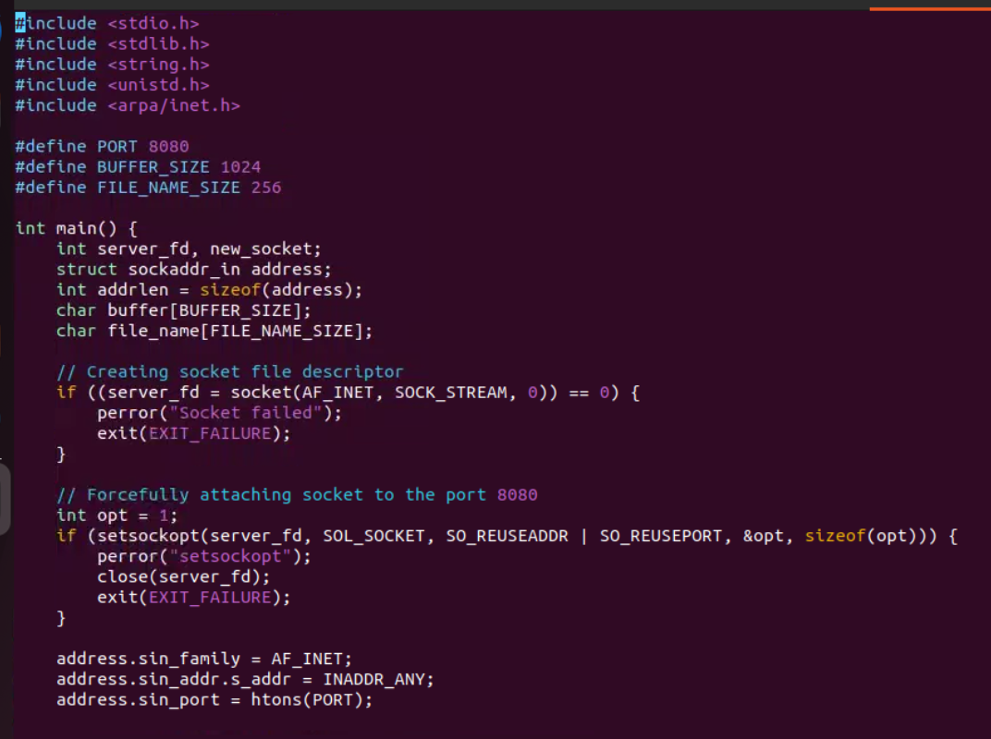

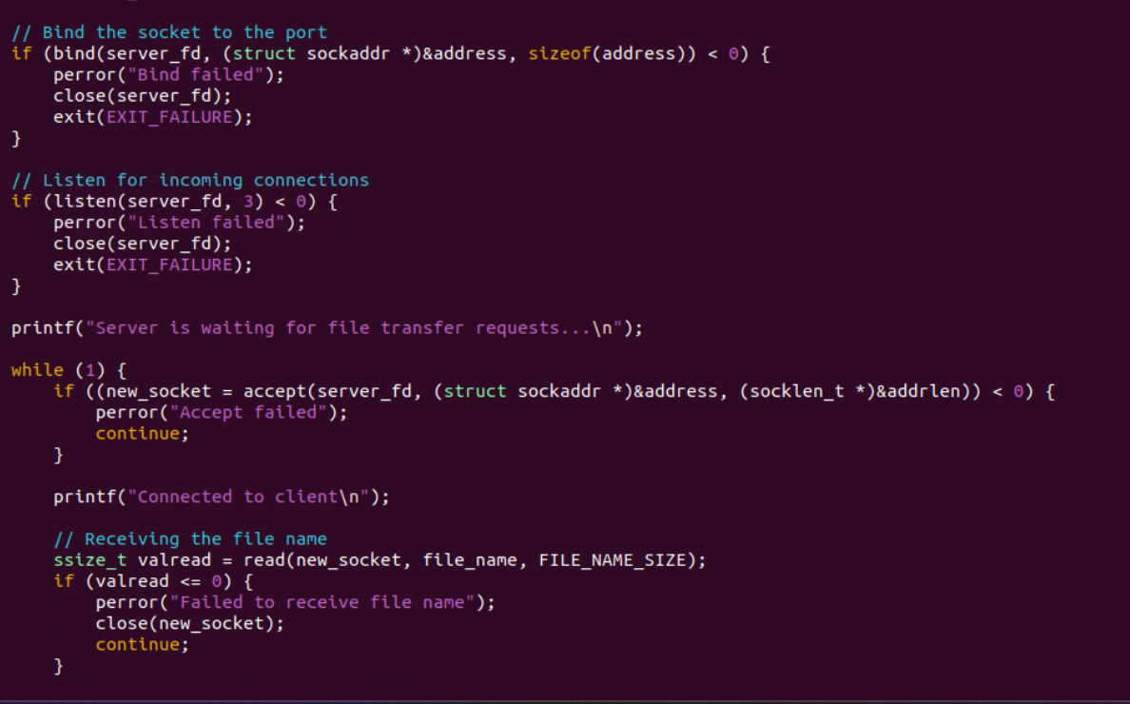

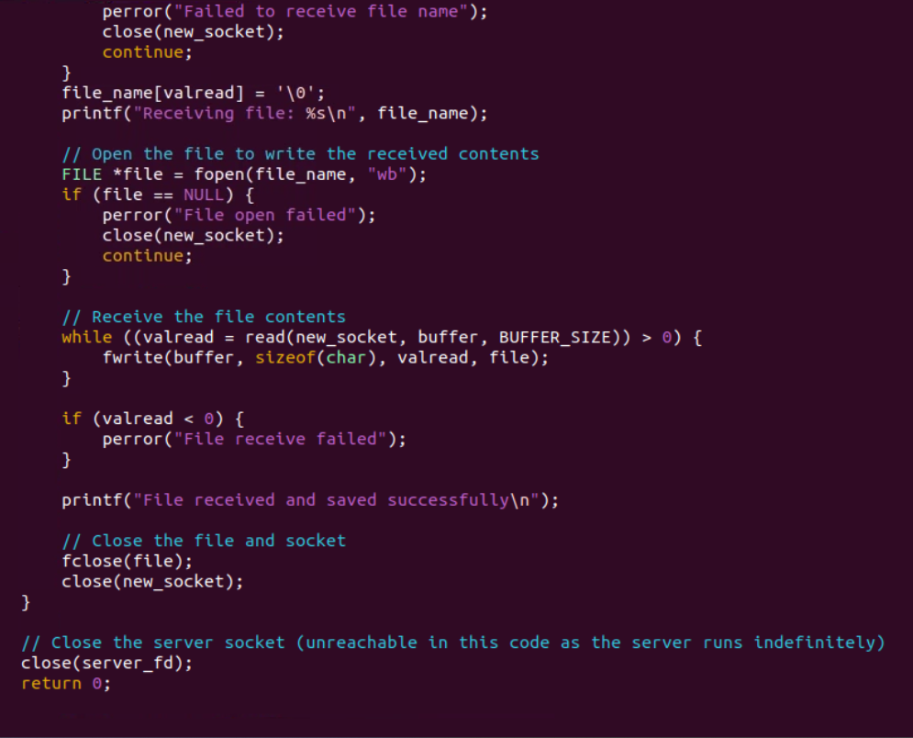

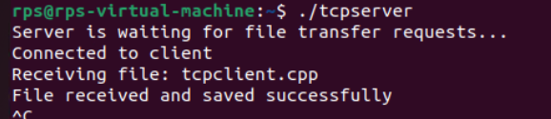

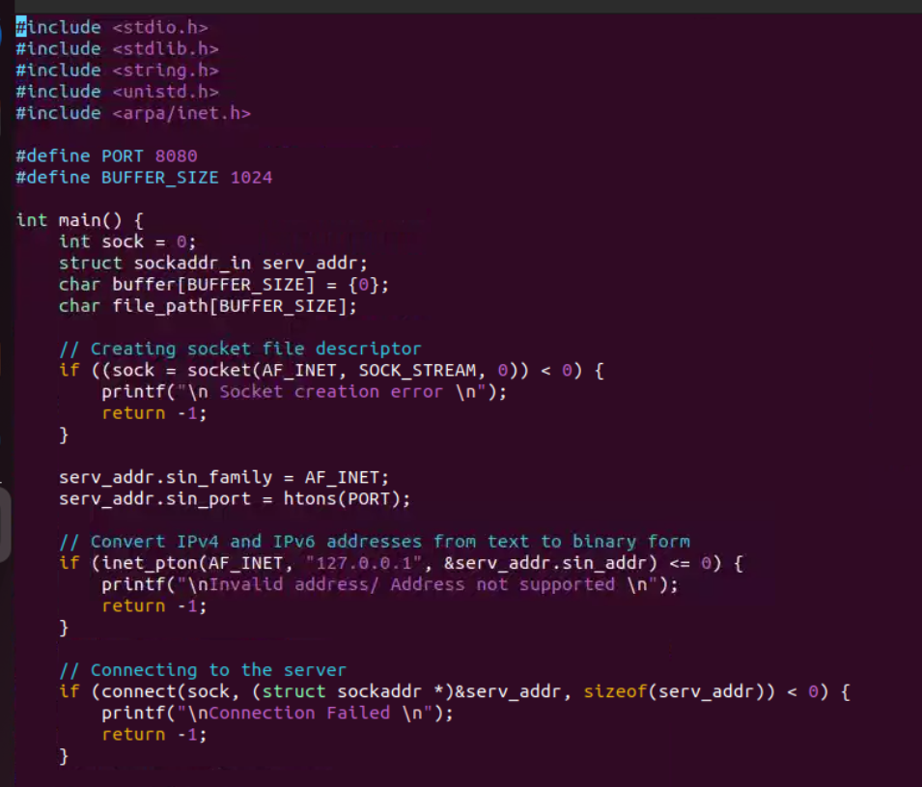

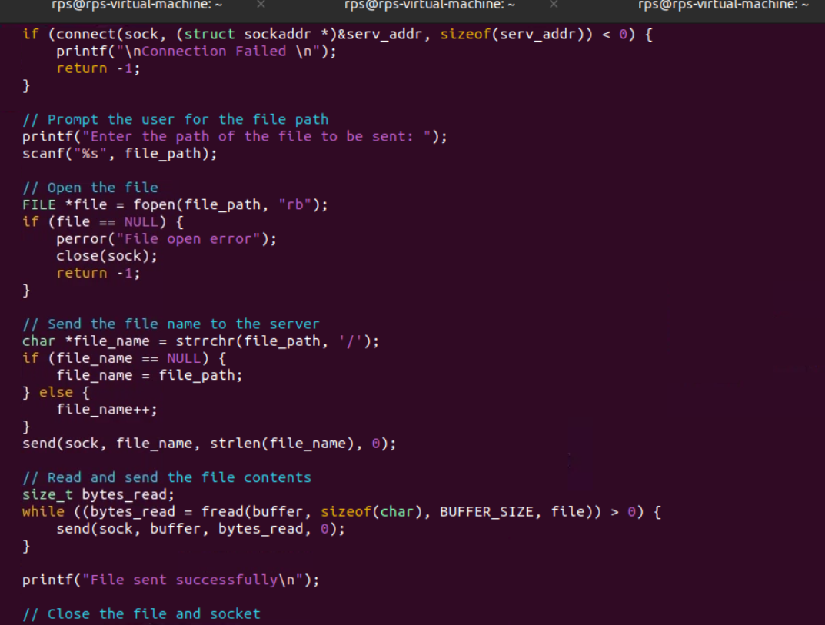

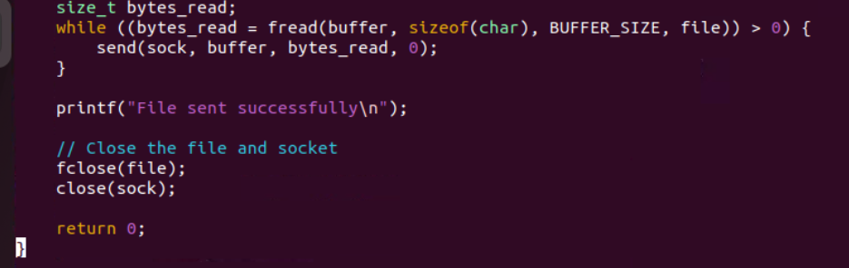

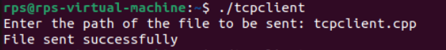

4.) Broadcast Messaging using UDP:

Problem Statement: Write a UDP server and client program in C to implement a simple broadcast messaging system. The server should broadcast a message to all clients in the network, and each client should display any broadcast messages it receives.

Requirements:

The server should send a broadcast message to a specific port.

Each client should listen on the same port and display any messages it receives.

Implement proper error handling and use UDP broadcast mechanisms.

Server code

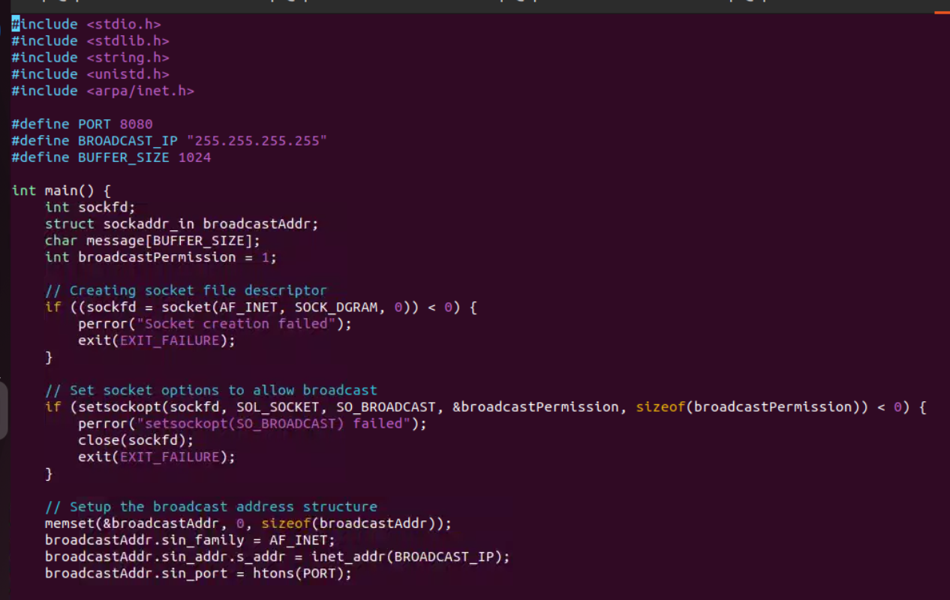

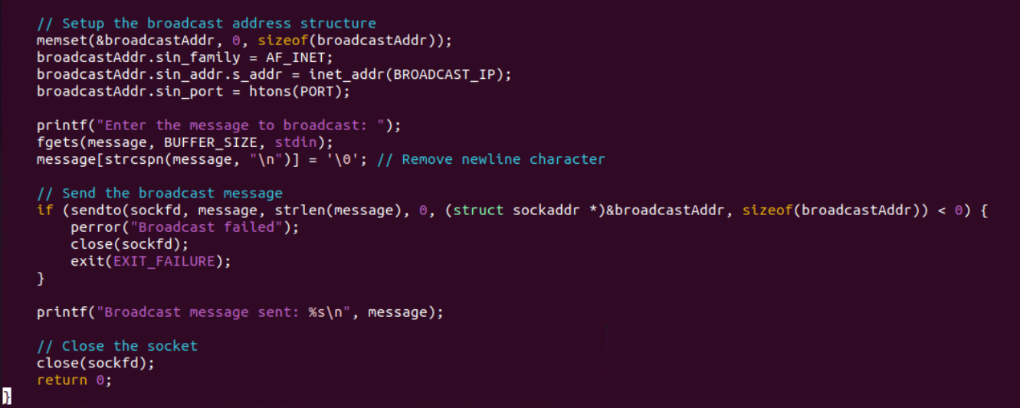

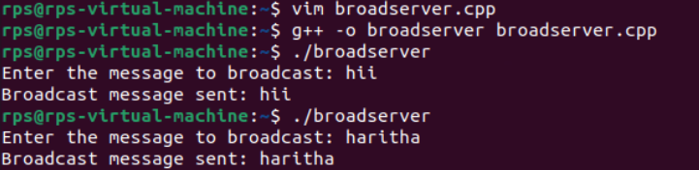

Client code

